PhD Training Plan

The doctoral student will establish the training plan in agreement with the supervising professor. The training plan (180 credits) consists of:
a) Carrying out, under the guidance of a supervisor, an individual research program approved by the PhD board and related to a disciplinary field within those provided by the PhD Course. The research activities carried out by the PhD student must be presented at the end of the three years in at least 3 scientific publications submitted to international indexed journals (ISI-SCOPUS journals), of which at least one already accepted for publication. At least in one paper the PhD student has to be the first author or corresponding author. The research program must include a period abroad at a certified University/research institution lasting at least six months (even non-continuous).
b) Engaging in complementary educational and training activities useful to carry out the research activity, in which the PhD student must earn at least 30 credits. These activities include:
- Attendance (and passing of any final exams) of specific courses (activities A and B, Tables A and B at the end of this file) on topics related to the two curricula of the PhD organized within the framework of the PhD in Biological and Naturalistic Sciences or other equivalent courses organized by other doctoral programs, including those abroad. The number of ECTS credits that can be acquired is indicated next to each course in the table. At the end of the three years the PhD student has to gain at least 12 ECTS belonging to activities A and B.
- Attendance (and passing of final exams) of courses related to soft skills (Table C, Table at the end of this file). The number of ECTS credits that can be acquired is indicated next to each course on the calendar. At the end of the three years the PhD student has to gain at least 6 ECTS belonging to activities C.
- Participation to the Summer School organized by the PhD board or to any other national or international schools related to the themes of the two curricula of the PhD (1 ECTS credits per day) or to national (0.5 ECTS credits per day) or international (1 ECTS credits per day) conferences on topics related to the two curricula of the PhD (activity D). At the end of the three years the PhD student has to gain at least 3 ECTS belonging to activities D.
- Participation to national (0. 5 ECTS per 6 hour) or international (1 ECTS per 6 hour) seminars (activity D) given by members of the PhD board of the PhD topics or by national and international experts on topics related to the two curricula of the PhD course.
- Scientific dissemination activities (scientific oral presentation personally given by the doctoral student) are recommended (no credits for this activity).
- The doctoral student can engage in supplementary teaching activities, didattica integrativa (maximum 30 hours each year) or tutoring activities (terza missione o tutoraggio) (maximum 30 hours each year) (no credits for this activity).
- At the end of the PhD program, the PhD student must have obtained an English language certificate at level C1. Phd students have the opportunity to participate in foreign language courses at the University's Language Center (CLA) and obtain certified assessment in individual language skills.
All training activities organized and/or suggested by the PhD program will be scheduled on the PhD website and communicated to students and PhD board via email. At the following link each student can find useful information about the PhD course in UNIPG https://www.unipg.it/didattica/percorsi-post-laurea/dottorati-di-ricerca
At the beginning of the PhD course (within the first 4 months), each PhD student presents its Individual training plan containing the research activities he intends to pursue and the educational activities he intends to follow. Before the 10 October of each academic year, the PhD student must submit to the coordinator the Annual Report (first/second) report concerning all the training and research activities carried out; the report, shared with the tutor, consists of a file containing the research results achieved within the framework of the PhD project and a brief report on other training and supplementary teaching/tutoring activities carried out during the same period, along with the report related to the credits obtained in the training activities. The reports will be evaluated by the PhD board, which, after consulting with the PhD student and the tutor regarding progress in thesis development, will, in case of a positive evaluation, allocate the respective credits (up to 30-40 ECTS credits for the annual report on research activities and/or thesis writing). The individual Phd course ends with the writing of the thesis. The thesis, written in English, must contribute to advancing knowledge or methodologies in the chosen field of study.
PhD students have a budget for research activities in Italy and abroad, with an amount not less than 10% of the scholarship. This amount is managed directly by the Department to which the doctoral program belongs. The research budget can be used for reimbursement of expenses incurred for missions or conference registrations, seminars, schools, expenses for thesis preparation, expenses for organizing seminars and conferences with external lecturers, purchase of consumables, services, and maintenance of equipment and instruments. In this context, a small amount of euros per doctoral student can be used for organizing the annual Summer School of the PhD in Biological and Natural Sciences (held every year) and other activities aimed at implementing the individual training plan of the PhD students.

CALENDARIO DELLE ATTIVITÀ FORMATIVE

Attività didattiche – tipologia A, B e C (come da linee guida di Ateneo per la definizione delle attività didattiche e formative nell’ambito dei corsi di dottorato di ricerca, approvate dagli OO.AA. in data 30 e 31 gennaio 2024)
A. Didattica frontale erogata dal Corso di Dottorato - ogni studente deve acquisire nel triennio almeno 12 cfu dei sottoindicati insegnamenti

Denominazione insegnamento | n. cfu (ore) | SSD insegna mento | Verifica finale | Docente | Tipologia  Docente* | Distribuzione durante il ciclo di dottorato (anni in cui l'insegnamento attivo) | Eventuale curriculum di riferimento
Electrophysiological approach through the patch clamp technique | 1(6) | BIO/09 | orale | Antonio  Michelucci | cc | I | PVBU
Diversity of Mediterranean freshwater fish | 1(6) | BIO/07 | orale | Massimo  Lorenzoni | cc | I | IOA
R for statistical analysis of data | 2(12) | BIO/05 | orale | Gianandrea  La Porta (ex L. 240, art 23, comma 1) | EE | I | Tutti i curricula
LIFE Programme: the EU's funding instrument for the environment | 1(6) | BIO/05 | orale | Matteo  Pallottini (ex L. 240, art 23, comma 1) | EE | I | IOA
Evaluation of metals environmental pollution: techniques and implications for biota and health | 1(6) | CHIM/12 | orale | Chiara  Petroselli (ex L. 240, art 23, comma 1) | EE | I | IOA
Climate change in the Arctic environment:  monitoring and future prospects | 1(6) | CHIM/O  7 | orale | David  Cappelletti | CAC | II | IOA
Molecular Dynamics techniques applied to biological macromolecules | 1(6) | BIO/09 | orale | Luigi  Catacuzzeno | cc | II | PVBU
Ecology of zoonoses: environmental changes and emergence of new viruses | 1(6) | MED/07 | orale | Barbara  Camilloni | cc | II | PVBU

Biological risk in the anthropic environment: analysis methods and impact on human health |  | 1(6) | BIO/19 | orale | Ermanno  Federici | cc | II | PVBU
Synergistic effects of climate change and biological invasions in Mediterranean freshwater ecosystems |  | 1(6) | BIO/07 | orale | Antonella Carosi | D | II | IOA
Microbial biofilms: biological and technological aspects |  | 1(6) | MED/07 | orale | Donatella Pietrella | cc | II | PVBU
Clustering and phylogeny in genomic investigations |  | 1(6) | BIO/18 | orale | Hovirag  Lancioni | cc | Il | IOA
Molecular epidemiology |  | 1(6) | MED/42 | orale | Roberto Fabiani | cc | II | PVBU
Microscopy techniques in functional morphology: from basic research to biomimetics |  | 1(6) | BIO/05 | orale | Manuela Rebora | cc | II | IOA
Insect sensory systems: techniques for electrophysiological and behavioural investigations |  | 1(6) | BIO/05 | orale | Silvana  Piersanti | cc | II | IOA
*scritta, orale, realizzazione di un elaborato (saggio, presentazione, etc…)
**componenti del Collegio dei docenti, studiosi ed esperti italiani e stranieri di elevato profilo provenienti dal mondo accademico, dagli Enti di ricerca, dalle aziende, dalle istituzioni culturali e sociali; indicare nome del Docente ove possibile o la tipologia del contratto da stipulare.

Legenda -C= Componente collegio; CAC = componente altro collegio; D= Docente UNIPG non del collegio; EE= esperto esterno.
B. Didattica frontale erogata da altri Corsi di Dottorato, qualora il Corso di Dottorato individui degli insegnamenti da suggerire ai propri studenti
Il Corso di dottorato suggerisce le sottoelencate attività, tuttavia il dottorando può scegliere in maniera autonoma ulteriori attività, per le quali saranno riconosciuti i relativi cfu secondo quanto previsto dalle Linee guida di Ateneo per la definizione delle attività didattiche e formative nell’ambito dei Corsi di dottorato di ricerca.

Denominazione insegnamento | n. cfu (ore) | SSD insegna mento | Verifica finale | Docente | Tipologia  Docente* | Distribuzione durante il ciclo di dottorato (anni in cui l'insegnamento attivo) | Eventuale curriculum di riferimento
Introduction to Data analysis and data formats | 2(12) | AGR/12 | orale | Gianluigi  Cardinali | Dottorato in  Biotecnologie | I | Tutti i curricula
Bibliographic databases, principles of bibliometrics and bibliography management | 1 (6) | AGR/11 | orale | Gianandrea Salerno | Dottorato in  Scienze e  Biotecnologie  Agrarie,  Alimentari e  Ambientali | I | Tutti i curricula
Lab Safety: chemical and biological risk | 1 (6) | AGR/13 | orale | Daniele Del Buono | Dottorato in  Scienze e  Biotecnologie  Agrarie,  Alimentari e  Ambientali | I | Tutti i curricula
Advanced experimental methods in biology | 4(24) | AGR/02 | orale | Andrea  Onofri | Dottorato in  Scienze e  Biotecnologie  Agrarie,  Alimentari e  Ambientali | II | Tutti i curricula
Raman microspectroscopy theory and applications | 3 (18) | CHIM/02 | orale | Paola Sassi | Dottorato in Scienze chimiche | II | Tutti i curricula
Writing EU  Research  Projects | 1 (6) |  | orale | Sara  Alimenti | Dottorato in Scienze chimiche | II | Tutti i curricula
*scritta, orale, realizzazione di un elaborato (saggio, presentazione, etc…)
Legenda/ Legend
PO = Professore ordinario (full professor), PA = professore Associato (associate professor), RTDa =
Ricercatore a tempo determinato di tipo A, R TDB = Ricercatore a tempo determinato di tipo B RU = Ricercatore
AC = tutti i curricula / all curricula
C-IOA = curriculum Interazione Organismo-Ambiente
C-PVBU = curriculum Processi Vitali e Benessere Umano

C. Didattica frontale e trasversale di Ateneo e/o di altro Corso di Dottorato a carattere multi/inter/trans-disciplinare - ogni studente deve acquisire nel triennio almeno 6 cfu dei sottoindicati insegnamenti
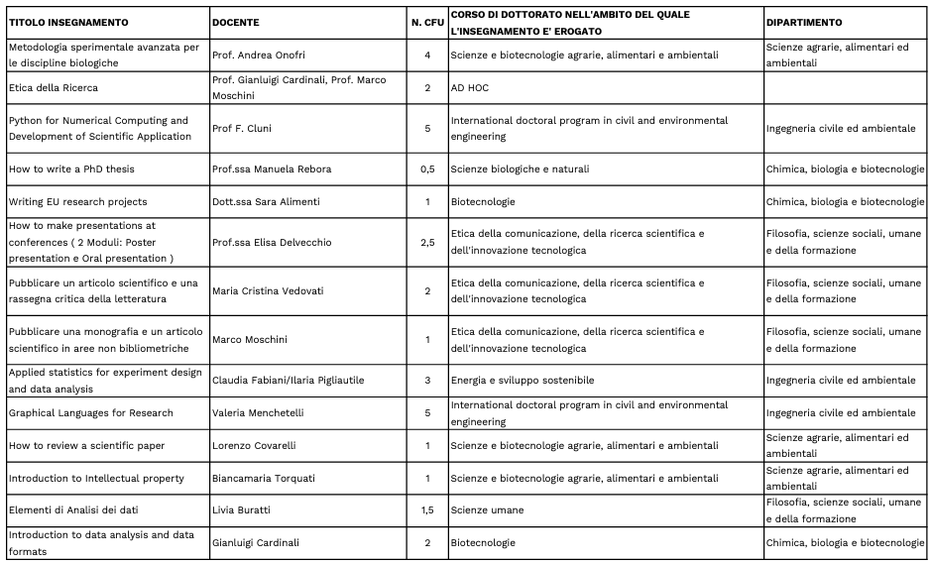
*scritta, orale, realizzazione di un elaborato (saggio, presentazione, etc…)

In aggiunta a tale corso ogni dottorando può scegliere nell’ambito degli insegnamenti riportati al seguente link (Didattica frontale e trasversale di Ateneo e/o di altro Corso di Dottorato a carattere multi/inter/trans-disciplinare):
https://www.unipg.it/didattica/percorsi-post-laurea/dottorati-di-ricerca

Attività didattiche – tipologia D (come da linee guida di Ateneo per la definizione delle attività didattiche e formative nell’ambito dei corsi di dottorato di ricerca, approvate dagli OO.AA. in data 30 e 31 gennaio 2024)
D. Attività congressuali, scuole dottorali e altri eventi scientifici - ogni studente deve acquisire nel triennio almeno 3 cfu
Il Corso di dottorato suggerisce le sottoelencate attività, tuttavia il dottorando può scegliere in maniera autonoma ulteriori attività, per le quali saranno riconosciuti i relativi cfu secondo quanto previsto dalle Linee guida di Ateneo per la definizione delle attività didattiche e formative nell’ambito dei Corsi di dottorato di ricerca.

Tipo di attività | Descrizione dell'attività (e delle modalità di accesso alle infrastrutture per i dottorati nazionali) | n. cfu (ore) | Eventuale curriculum di riferimento | Documentazione richiesta*
Summer school del Dottorato in Scienze Biologiche e Naturali (annuale) | Due giornate all'anno di incontro e confronto con esperti nazionali e internazionali, docenti, ricercatori, dottorandi di altri dottorati, rappresentanti di enti pubblici e privati sulle tematiche che caratterizzano i due curricula del dottorato "Processi vitali e benessere umano" "Interazione organismo-ambiente" | 6 CF U in totale (due giornate per ogni anno, 1 CFU ogni giorno) | Tutti i curricula | Attestato di frequenza
*attestato di frequenza/attestato di partecipazione, etc…

